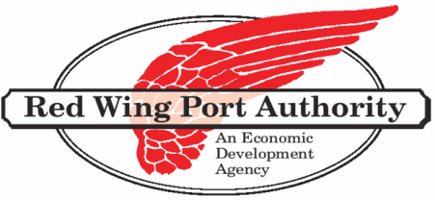
Business Assistance
Loan Programs
The Red Wing Port Authority operates a large loan portfolio to healthy and expanding businesses that have the highest probability of creating new jobs.
We provide:
- Long term
- Low down payment
- Reasonably priced financing
The Red Wing Port Authority has a variety of financing tools available including the following:
- JOBZ Program (Job Opportunity Building Zones)
- Local revolving loan funds
- Industrial Revenue Bonds
- Minnesota Investment Fund
- SBA 504 Loan
- Trillion BTU Energy Efficiency Loan program
- Entrepreneurial Loan Fund
With our experienced staff we can help put your financial package together to help your business grow!
RED WING PORT AUTHORITY REVOLVING LOAN FUND
TYPICAL AMOUNT | $150,000
USE OF PROCEEDS | Equipment, Machinery, Building Rehabilitation, Real Estate
INTEREST RATE | 5-8%
MATURITY DATE | 7 years
TYPICAL PACKAGE | 20-40% of project

SBA SECTION 504 LOANS
MAXIMUM AMOUNT | The lesser of $1,500,000 ($2,000,000 in certain situations) or 40% of project costs.
USE OF PROCEEDS | Fixed asset financing (land, building, equipment)
INTEREST RATE | Fixed
MATURITY DATE | 10 years for equipment, 20 years for land and building.
TYPICAL PACKAGE | 50% from Bank, 40% from 504, 10% equity injection.
(U.S. Small Business Administration (SBA) Program)

Red Wing Port Authority 315 West 4th Street Red Wing, MN 55066 651-385-3639 www.redwingportauthority.org

